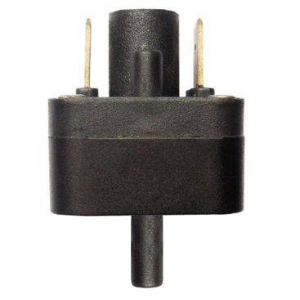

**Type ZA**

**Medium pressure, slow action contact differential pressure switches, 6.35 x 0.8mm terminals**

Uses: Low voltage, high sensivity.

Main applications: Detection of medium positive, negative or differential pressure.

Fluid: water or air (no liquid input on the negative pressure inlet).

Fitting: two plastic spouts dia 4 mm for soft PVC tube 3x6 mm (1/8”).

Pressure: Differential.

Contact: single pole normally open, slow action.

Electrical rating:

- Silver contact: max 1A 250V.

- Gold plated contact: max 100 mA, 24V.

Action: momentary, close by pressure rise on positive pressure inlet.

Set point calibration limits: from 10 to 400 mbar.